STOCK CFN ADAPTER
Quotes and Trade Reporting to SIAC
=============================================================

This is a simple guideline when testing StockCFNAdapter that will cover these points:

1. Trade reporting to SIAC
- Trade report. Only round lot portion of the trade will be reported. Odd lot trade will be ignored and not reported to SIAC.
- Trade cancel, if busted quantity is equal to original trade quantity than trade cancel will be created. If the original trade is odd lot trade than nothing is done.
- Trade correction, if busted quantity is less than original trade quantity, trade correction will be created if the round lot portion of the new quantity is greater than zero, otherwise trade cancel will be created.
- Prior day trade report, only round lot portion of the trade will be reported.
- Prior day trade cancel, if busted quantity is equal to original trade quantity than trade cancel will be created. If the original trade is odd lot trade than nothing is done.
- Prior day trade correction, if busted quantity is less than original trade quantity the trade correction will be created if the round lot portion of the new quantity is greater than zero.

2. Quote reporting:
CFNAdapter will listen to the current market event once the product is open and will stop listening if the product is halted or closed.

3. SIAC Reference table (SIAC_REFERENCE_NBR).
This table will have all the trade, trade correction and trade cancel data sent to SIAC.
Column definition:
- TRADEID (in long format) if you want in struct format use longToStruct scripts to convert it.
- TIME, trade date.
- PRODUCT, product key
- REFNUMBER, (in long) this will be converted into hex value and used as SIAC regional reference number.
- PRICE, trade price
- QUANTITY, trade quantity.
- ORIGINALREFERENCE, this will have value zero if a trade report and will have original REFNUMBER > 0 if it is a cancel or correction.
If quantity is zero this is a cancel otherwise it is a correction.
- SETTLEMENDATE, (long format). Trade settlement date. Use longtodate script to get the date

Next is the sample of the table being created after the test.
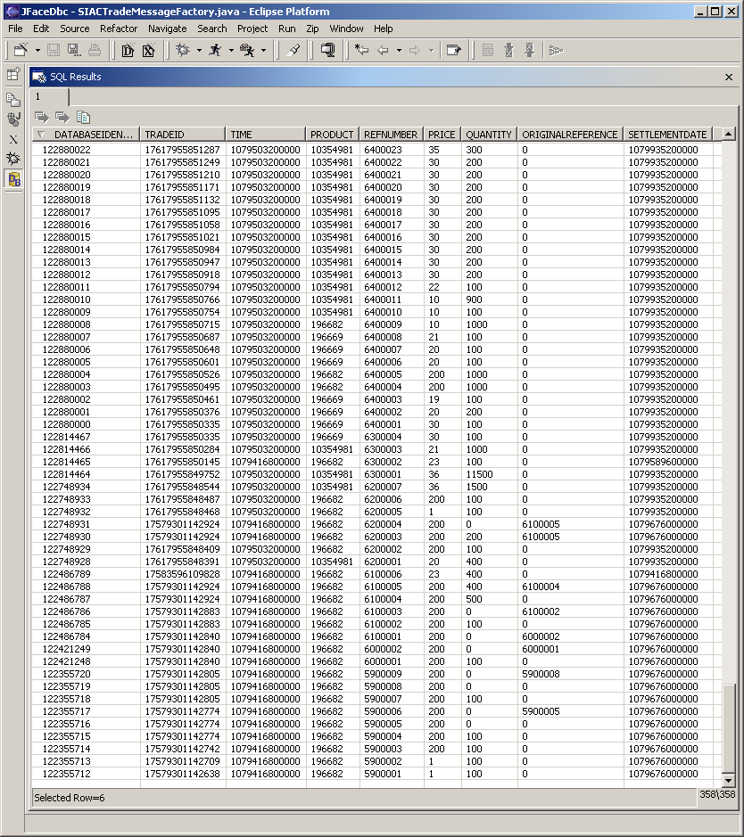

- SIAC Reject/error.
Any error message from SIAC will be logged in log file, and can be configured to sent the message to help desk too. (Run “ar StockCFNAdapter sendErrorToHelpDesk”, which will turn on the feature to send the error message to SA GUI/help desk).

Sample of error message from SIAC:

low information 2004/3/18 10:11:23.10 StockCFNAdapter StockCFNAdapterClient:devenv1(170.137.230.98) "<default log> SIAC-ERROR:ERROR_INVALID_BID_SIZE::ARSIWQ000001048ADWQSI000006015d142fC AAAZ B000000000100000005000000000000000000000 " 0
low information 2004/3/18 10:45:11.98 StockCFNAdapter StockCFNAdapterClient:devenv1(170.137.230.98) "<default log> SIAC-ERROR:ERROR_ORIGINAL_TRANSACTION_NOT_FOUND::ARSIWT0000010663be162TCWTSI00000501663be161a80400C B0B000000000000000 000 000000020000000000900
Testing Plan

QUOTE
Tail the StockCFNAdapter.log

1. Enter a quote or order to create a new current Market. New quote will be received by StockCFN and will be logged in the log file.
low information 2004/3/18 11:17:13.02 StockCFNAdapter StockCFNAdapterClient:devenv1(170.137.230.98) "<default log> **********QuoteReport**********
REF. NBR:602169
SYMBOL:C
QUOTE COND.:R
MARKET COND.:A
BID PRICE:1.0
BID SIZE :3
ASK PRICE:75.0
ASK SIZE :3" 0

2. Enter an odd lot order, and nothing is logged in the log file.

3. Hit current market bid to create a trade. A Trade and new current market will be published (in this case one side quote will be generated).
low information 2004/3/18 11:18:26.51 StockCFNAdapter StockCFNAdapterClient:devenv1(170.137.230.98) "<default log> **********QuoteReport**********
REF. NBR:60216c
SYMBOL:C
QUOTE COND.:N
MARKET COND.:A
BID PRICE:0.0
BID SIZE :0
ASK PRICE:1.0
ASK SIZE :27" 0
low information 2004/3/18 11:18:26.52 StockCFNAdapter StockCFNAdapterClient:devenv1(170.137.230.98) "<default log> **************TradeReport*************
REF NBR:663bea
SYMBOL:C
PRICE:1.0
TIME:3182004 111826
QTY:300
STATUS:1
SALE COND:
S SALE DAYS:0
STOP STK IND:0
LOCAL ISS IND:0
ISSUE TYPE:0
OUTPUT NET:A
" 0
low information 2004/3/18 11:18:26.52 StockCFNAdapter StockCFNAdapterClient:devenv1(170.137.230.98) "<default log> CFNTradeConsumerImpl.acceptTradeReport:4104:424" 0

4. Cancel the quote, this will send a zero quote to SIAC.
low information 2004/3/18 11:23:16.01 StockCFNAdapter StockCFNAdapterClient:devenv1(170.137.230.98) "<default log> **********QuoteReport**********
REF. NBR:60216e
SYMBOL:C
QUOTE COND.:N
MARKET COND.:A
BID PRICE:0.0
BID SIZE :0
ASK PRICE:0.0
ASK SIZE :0" 0

5. Close the product, this will make StockCFN stop listening to the current market event and zero quote will be sent to SIAC:
low information 2004/3/18 12:51:44.06 StockCFNAdapter StockCFNAdapterClient:devenv1(170.137.230.98) "<default log> CFNQuoteConsumerImpl.acceptCurrentMarketStateChangeV2 - 196680:1" 0
low information 2004/3/18 12:51:44.06 StockCFNAdapter StockCFNAdapterClient:devenv1(170.137.230.98) "<default log> **********QuoteReport**********
REF. NBR:60218f
SYMBOL:C
QUOTE COND.:N
MARKET COND.:A
BID PRICE:0.0
BID SIZE :0
ASK PRICE:0.0
ASK SIZE :0" 0
low information 2004/3/18 12:51:44.06 StockCFNAdapter StockCFNAdapterClient:devenv1(170.137.230.98) "<default log> Removing inclusion filter for class:196680" 0

6. Set product state to pre open:
low information 2004/3/18 12:54:08.15 StockCFNAdapter StockCFNAdapterClient:devenv1(170.137.230.98) "<default log> CFNQuoteConsumerImpl.acceptCurrentMarketStateChangeV2 - 196680:2" 0

7. Send a quote to create new current market, StockCFN should not receive current market for this product.

8. Open Product, quote will be sent to SIAC
low information 2004/3/18 12:56:17.22 StockCFNAdapter StockCFNAdapterClient:devenv1(170.137.230.98) "<default log> **********QuoteReport**********
REF. NBR:602192
SYMBOL:C
QUOTE COND.:R
MARKET COND.:A
BID PRICE:1.0
BID SIZE :3
ASK PRICE:75.0
ASK SIZE :3" 0
StockCFNAdapterClient:devenv1(170.137.230.98) "<default log> Applying inclusion filter for class:196680" 0

TRADE

Trade report
Trade report has been created , continue to trade correction.

Trade correction
Using SA GUI bust the trade (in log file you will se the trade id, look for the line "CFNTradeConsumerImpl.acceptTradeReport:"
In this example, I have 300 trade with trade id 4104:424,
Bust 100 shares. Trade correction will be generated.
low information 2004/3/18 11:28:16.97 StockCFNAdapter StockCFNAdapterClient:devenv1(170.137.230.98) "<default log> *******TradeCorrection******
Origianal Trade******************
REF NBR:663bea
SYMBOL:C
PRICE:1.0
TIME:3182004 111826
QTY:300
STATUS:1
SALE COND:
S SALE DAYS:0
STOP STK IND:0
LOCAL ISS IND:0
ISSUE TYPE:0
OUTPUT NET:A
New Trade **********************
REF NBR:663bed
SYMBOL:C
PRICE:1.0
TIME:3182004 111826
QTY:200
STATUS:1
SALE COND:
S SALE DAYS:0
STOP STK IND:0
LOCAL ISS IND:0
ISSUE TYPE:0
OUTPUT NET:A
LAST TICK:0
LAST PRICE:0.0" 0
low information 2004/3/18 11:28:16.97 StockCFNAdapter StockCFNAdapterClient:devenv1(170.137.230.98) "<default log> CFNTradeConsumerImpl.acceptTradeBustRepor-4104:424" 0
- Trade cancel
Bust the same trade with bust quantity 150. Trade cancel will be created. (Why not trade correction? the answer is because the new trade will have odd lot size and we don't report odd lot trade):
low information 2004/3/18 11:31:39.85 StockCFNAdapter StockCFNAdapterClient:devenv1(170.137.230.98) "<default log> **********TradeCancel***********
REF NBR:663bee
ACTION:0
INDICATOR:1
LAST TICK:0
LAST PRICE:0.0
Canceled Trade**********
REF NBR:663bed
SYMBOL:C
PRICE:1.0
TIME:3182004 111826
QTY:200
STATUS:1
SALE COND:
S SALE DAYS:0
STOP STK IND:0
LOCAL ISS IND:0
ISSUE TYPE:0
OUTPUT NET:A
" 0
low information 2004/3/18 11:31:39.86 StockCFNAdapter StockCFNAdapterClient:devenv1(170.137.230.98) "<default log> CFNTradeConsumerImpl.acceptTradeBustRepor-4104:424" 0

Create Odd lot Trade
Create odd lot trade, trade will not reported to SIAC.
low information 2004/3/18 13:19:55.13 StockCFNAdapter StockCFNAdapterClient:devenv1(170.137.230.98) "<default log> CFNTradeConsumerImpl.acceptTradeReport:4107:266" 0

Cancel odd lot trade
Cancel the odd lot trade, nothing should be reported to SIAC
low information 2004/3/18 13:22:35.32 StockCFNAdapter StockCFNAdapterClient:devenv1(170.137.230.98) "<default log> CFNTradeConsumerImpl.acceptTradeBustRepor-4107:266" 0

Create mixed lot trade
Create mixed lot trade (150 shares), only round lot portion will be reported to SIAC
low information 2004/3/18 13:24:14.57 StockCFNAdapter StockCFNAdapterClient:devenv1(170.137.230.98) "<default log> **************TradeReport*************
REF NBR:663bf5
SYMBOL:C
PRICE:75.0
TIME:3182004 132414
QTY:100
STATUS:1
SALE COND:
S SALE DAYS:0
STOP STK IND:0
LOCAL ISS IND:0
ISSUE TYPE:0
OUTPUT NET:A
" 0
low information 2004/3/18 13:24:14.57 StockCFNAdapter StockCFNAdapterClient:devenv1(170.137.230.98) "<default log> CFNTradeConsumerImpl.acceptTradeReport:4107:299" 0

Cancel mixed lot trade
Cancel the mixed lot trade, only round lot portion will be reported to SIAC.
low information 2004/6/7 16:43:01.00 StockCFNAdapter StockCFNAdapterClient:devenv2(170.137.230.99) "<default log> **********TradeCancel***********
REF NBR:a34505
ACTION:0
INDICATOR:1
LAST TICK:0
LAST PRICE:0.0
Canceled Trade**********
REF NBR:a34504
SYMBOL:QQQ
PRICE:36.720000000
TIME:672004 163810
QTY:100
STATUS:1
SALE COND:
S SALE DAYS:0
STOP STK IND:0
LOCAL ISS IND:0
ISSUE TYPE:0
OUTPUT NET:B
" 0
low information 2004/6/7 16:43:01.00 StockCFNAdapter StockCFNAdapterClient:devenv2(170.137.230.99) "<default log> CFNTradeConsumerImpl.acceptTradeBustRepor-4824:1872" 0

Prior day trade correction
Create more trade, don't cancel or correct and wait until the next day to do cancel or correction. The next day when you do cancel or correction the log will be like this if the busted quantity is less than the original trade quantity and the remaining trade quantity is greater than 100.

PRIOR DAY TRADE CORRECTION
low information 2004/3/18 10:45:08.87 StockCFNAdapter StockCFNAdapterClient:devenv1(170.137.230.98) "<default log> *******PriorDayTradeCorrection******
Origianal Trade******************
REF NBR:61a804
SYMBOL:C
PRICE:200.0
TIME:3172004 16219
QTY:1000
STATUS:1
SALE COND:
S SALE DAYS:0
STOP STK IND:0
LOCAL ISS IND:0
ISSUE TYPE:0
OUTPUT NET:A
New Trade **********************
REF NBR:663be1
SYMBOL:C
PRICE:200.0
TIME:3172004 16219
QTY:900
STATUS:1
SALE COND:
S SALE DAYS:0
STOP STK IND:0
LOCAL ISS IND:0
ISSUE TYPE:0
OUTPUT NET:A
LAST TICK:0
LAST PRICE:0.0" 0
low information 2004/3/18 10:45:08.89 StockCFNAdapter StockCFNAdapterClient:devenv1(170.137.230.98) "<default log> CFNTradeConsumer
Impl.acceptTradeBustRepor-4102:2303" 0

Prior day trade cancel
Bust a prior day trade. If the busted quantity is less than the original trade quantity and the remaining trade quantity is less than 100, the log will be like this:

PRIOR DAY TRADE CANCEL
low information 2004/3/18 10:55:43.07 StockCFNAdapter StockCFNAdapterClient:devenv1(170.137.230.98) "<default log> **********PriorDayTradeCancel***********
Prior Day Trade**********
REF NBR:61a804
SYMBOL:C
PRICE:200.0
TIME:3172004 16219
QTY:600
STATUS:1
SALE COND:
S SALE DAYS:0
STOP STK IND:0
LOCAL ISS IND:0
ISSUE TYPE:0
OUTPUT NET:A
INDICATOR:1
" 0
low information 2004/3/18 10:55:43.07 StockCFNAdapter StockCFNAdapterClient:devenv1(170.137.230.98) "<default log> CFNTradeConsumer
Impl.acceptTradeBustRepor-4102:2303" 0

- Prior day trade cancel with trade quantity less than 100
Bust a prior day trade with trade quantity less than 100. Nothing should be reported to SIAC:
low information 2004/6/8 13:45:24.35 StockCFNAdapter StockCFNAdapterClient:devenv2(170.137.230.99) "<default log> CFNTradeConsumerImpl.acceptTradeBustRepor-4824:1802" 0

DONE ORDER ENTRY

- Prior day trade with trade quantity >= 100
Using SA GUI create an as of trade with trade quantity >= 100, this will generate a prior day trade report to SIAC.
low information 2004/3/18 11:47:52.97 StockCFNAdapter StockCFNAdapterClient:devenv1(170.137.230.98) "<default log> PriorDayTradeReport
REF NBR:663bef
SYMBOL:C
PRICE:1.0
TIME:3172004 11479
QTY:300
STATUS:1
SALE COND:
S SALE DAYS:0
STOP STK IND:0
LOCAL ISS IND:0
ISSUE TYPE:0
OUTPUT NET:A
" 0
low information 2004/3/18 11:47:52.98 StockCFNAdapter StockCFNAdapterClient:devenv1(170.137.230.98) "<default log> CFNTradeConsumerImpl.acceptTradeReport:4104:568" 0

- Prior day trade with trade quantity < 100
Using SA GUI create an as of trade with trade quantity < 100, Nothing should be reported to SIAC:
Low information 2004/6/8 14:07:03.45 StockCFNAdapter StockCFNAdapterClient:devenv2(170.137.230.99) "<default log> CFNTradeConsumerImpl.acceptTradeReport:4837:133" 0

- Regular trade
Using SA GUI create a regualr trade, this will generate a trade report to SIAC with SALE CONDITION ‘ ‘:
low information 2004/6/8 14:18:07.45 StockCFNAdapter StockCFNAdapterClient:devenv2(170.137.230.99) "<default log> **************TradeReport*************
REF NBR:a4cb87
SYMBOL:QQQ
PRICE:36.810000000
TIME:682004 135222
QTY:1200
STATUS:1
SALE COND: =============================> REGULAR TRADE
S SALE DAYS:0
STOP STK IND:0
LOCAL ISS IND:0
ISSUE TYPE:0
OUTPUT NET:B
" 0
low information 2004/6/8 14:18:07.45 StockCFNAdapter StockCFNAdapterClient:devenv2(170.137.230.99) "<default log> CFNTradeConsumerImpl.acceptTradeReport:4837:141" 0

- Cash trade
Using SA GUI create a cash trade, this will generate a trade report to SIAC with SALE CONDITION ‘C’:
low information 2004/3/18 11:52:04.22 StockCFNAdapter StockCFNAdapterClient:devenv1(170.137.230.98) "<default log> **************TradeReport*************
REF NBR:663bf0
SYMBOL:C
PRICE:23.0
TIME:3182004 11479
QTY:500
STATUS:1
SALE COND:C =============================> CASH TRADE
S SALE DAYS:0
STOP STK IND:0
LOCAL ISS IND:0
ISSUE TYPE:0
OUTPUT NET:A
" 0
low information 2004/3/18 11:52:04.22 StockCFNAdapter StockCFNAdapterClient:devenv1(170.137.230.98) "<default log> CFNTradeConsumerImpl.acceptTradeReport:4104:580" 0

- Next day trade
Using SA GUI create a next day trade, this will generate a trade report to SIAC with SALE CONDITION ‘D’:
low information 2004/6/8 14:21:23.22 StockCFNAdapter StockCFNAdapterClient:devenv2(170.137.230.99) "<default log> **************TradeReport*************
REF NBR:a4cb89
SYMBOL:QQQ
PRICE:36.830000000
TIME:682004 135222
QTY:954400
STATUS:1
SALE COND:D ===========================> NEXT DAY TRADE
S SALE DAYS:0
STOP STK IND:0
LOCAL ISS IND:0
ISSUE TYPE:0
OUTPUT NET:B
" 0
low information 2004/6/8 14:21:23.22 StockCFNAdapter StockCFNAdapterClient:devenv2(170.137.230.99) "<default log> CFNTradeConsumerImpl.acceptTradeReport:4837:149" 0

- Sold trade
Using SA GUI create a sold trade, this will generate a trade report to SIAC with SALE CONDITION ‘Z’:
low information 2004/6/8 14:35:17.06 StockCFNAdapter StockCFNAdapterClient:devenv2(170.137.230.99) "<default log> **************TradeReport*************
REF NBR:a4cb8b
SYMBOL:QQQ
PRICE:36.860000000
TIME:682004 135222
QTY:600
STATUS:1
SALE COND:Z ===========================> SOLD TRADE
S SALE DAYS:0
STOP STK IND:0
LOCAL ISS IND:0
ISSUE TYPE:0
OUTPUT NET:B
" 0
low information 2004/6/8 14:35:17.06 StockCFNAdapter StockCFNAdapterClient:devenv2(170.137.230.99) "<default log> CFNTradeConsumerImpl.acceptTradeReport:4837:157" 0

